Executive Summary

This excerpt from the recent HEPAP Subpanel Report gives strong support to the LHC Detector Upgrades and Luminosity Upgrades:
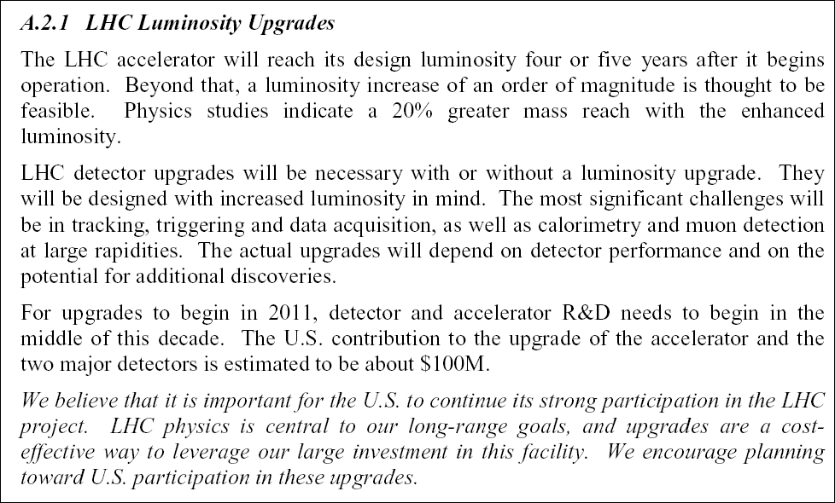

The luminosity of the LHC will increase over the first several years of operation, reaching 10³⁴ cm⁻²s⁻¹ and requiring detector upgrades in critical areas. Modest LHC upgrades, for which the U.S. National Labs are uniquely positioned to play a leading role, should increase the luminosity to 10³⁵ cm⁻² s⁻¹, extend the physics reach of the LHC and require challenging improvements in the detectors [1]. A possible later upgrade of the LHC collision energy by a factor of two will be studied.

The Luminosity Upgrade will extend the LHC mass reach by about 20% which is important in searches for sequential electroweak bosons and extra dimensions. The measurement of rare Higgs decays and the study Higgs self-coupling is also greatly enhanced. A doubling of the energy, if feasible, would almost double the mass reach [2].

Many of the detectors will need more resistance to radiation. Greater granularity in the tracking systems will be needed to preserve performance at increased luminosity, and this will require their replacement for the Luminosity Upgrade. Innovations to provide better triggers and rate capability will also be needed. All these enhancements require extensive R&D.

The time scale for the Luminosity Upgrade is 2012-2015, requiring that the R&D on the detectors and accelerator components start now to make this possible. Costs for initial R&D are part of the LHC Research Program. The Upgrades themselves will require new funding. The total cost for the U.S. will likely be in the $150M range. An energy upgrade would take place on a longer time scale.
1. Physics Motivation for the Upgrades

There have been preliminary studies of the physics impact of upgrades to both the LHC luminosity and the C.M. energy. These have focused on a luminosity upgrade of a factor of ten (called the SLHC below) and a doubling of the energy.

Luminosity
The standard model Higgs boson, if it exists, will be discovered at the LHC and many of its properties determined. A ten-fold increase in the event sample would potentially allow the observation of two new decay modes. The decay H->Zγ followed by the decay of the Z to either e⁺e⁻ or μ⁺μ⁻ for Higgs masses in the range 110 to 160 GeV becomes clearly observable (11 σ) with an integrated luminosity of 3000 fb⁻¹. The decay H to μ⁺μ⁻ has a branching ratio of order 0.0001. It may be possible to observe this channel with the full design luminosity but only via the vector boson fusion process. The luminosity upgrade will enable the channel to be observed via the gluon-gluon production process which is much less demanding of detector performance. Other final states such as WH to lνγγ, which have limited samples at design luminosity, will also benefit from the luminosity upgrade

The increases in the samples for these and other final states would enable the measurements from them to reach the precision constrained by systematic limits, and would therefore fully exploit the capabilities of a 14 TeV collider for this physics. For a limited range of Higgs masses, the luminosity upgrade would allow the observation of final states containing pairs of Higgs bosons via their decays into final states containing W bosons. This measurement is important as it will provide the first direct information on the self-coupling of the Higgs bosons. For example, for a Higgs mass of 170 GeV, a measurement of the Higgs self-coupling with an error of 20% should be achievable.

The full exploitation of the luminosity upgrade for Higgs physics is particularly demanding of the detector. The observed particles are at relatively low energy where the impact of pileup is expected to be most severe. Most critical is the ability to tag jets of transverse energy of order 100 GeV in the forward region and to veto jets of comparable transverse energy in the central region. A simulation was carried out to assess the impact of the additional pile-up at 10³⁵cm⁻²s⁻¹. While the performance does degrade, the fake rates can be kept low enough by adjusting the selection criteria so that the tagging and vetoing remain effective. A simulation of the effect on a heavy Higgs signal shows that if one maintains the same signal to background ratio after a luminosity upgrade, the signal rate increases by a factor of six for a factor of ten increase in the luminosity.

The study of the high-energy behavior of weak interactions is a vital part of the LHC program as it can yield information about the dynamics responsible for electroweak symmetry breaking. The measurement of final states containing multiple gauge bosons is used to extract information on the self-couplings of the W, Z and photon. Final states containing three gauge bosons become observable at the LHC after a luminosity upgrade.
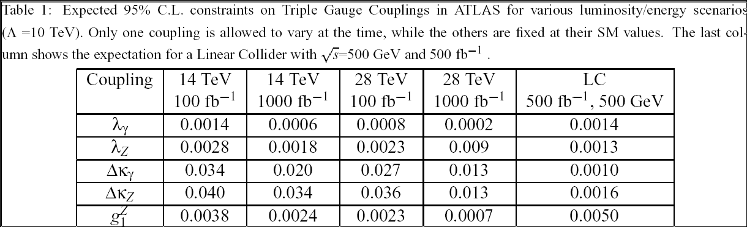
For example the final state WZZ where all the gauge bosons decay subsequently to easily observable leptonic decays results in approximately 500 events for an integrated luminosity of 3000 fb⁻¹. The impact of the additional luminosity on the precision obtainable on the gauge boson self-couplings is shown in Table 1. For comparison this Table also shows the impact of an energy upgrade by a factor of two.

The search for new particles can also benefit from a luminosity upgrade. In these cases the detected objects have large transverse momenta and the effects of pileup on detector performance are much less critical. As examples we show here the increase in sensitivity to extra dimensions, new gauge bosons and supersymmetry. Results of these studies are shown in Fig.1- Fig. 3 respectively.

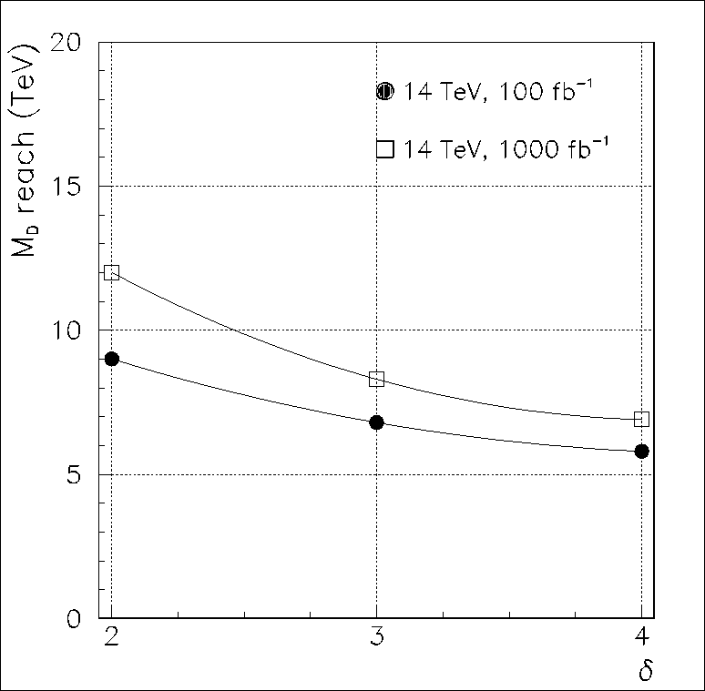
Quite generally, the mass reach for discovery level processes is increased by ~ 30% for a luminosity increase of a factor of ten. In the case of extra dimensions, the signal is revealed as an excess of events with very high transverse energy jets and missing transverse energy as the produced graviton excitations do not interact in the detector. The signal for a new neutral gauge boson is a peak in the e⁺e⁻ or μ⁺μ⁻ invariant mass distribution at high mass. Supersymmetry is revealed by an excess of events with very energetic jets, leptons and missing transverse energy. The reach for gluino masses, for example, is extended beyond 3 TeV by a luminosity upgrade.

Figure 1: Sensitivity to the scale of extra dimensions as a function of the number of extra dimensions at the LHC showing the effect of the luminosity upgrade.

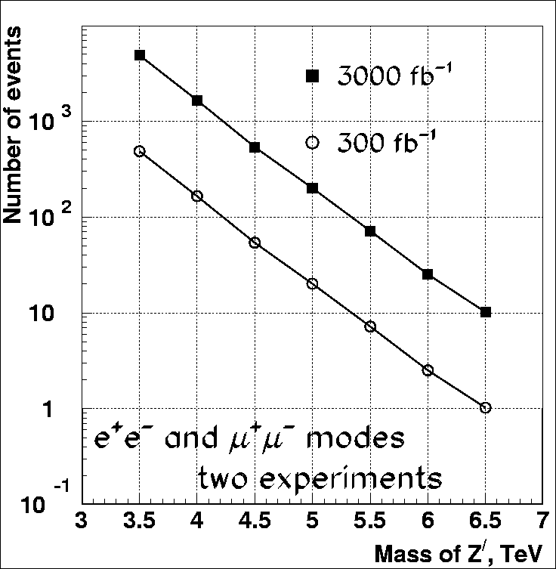

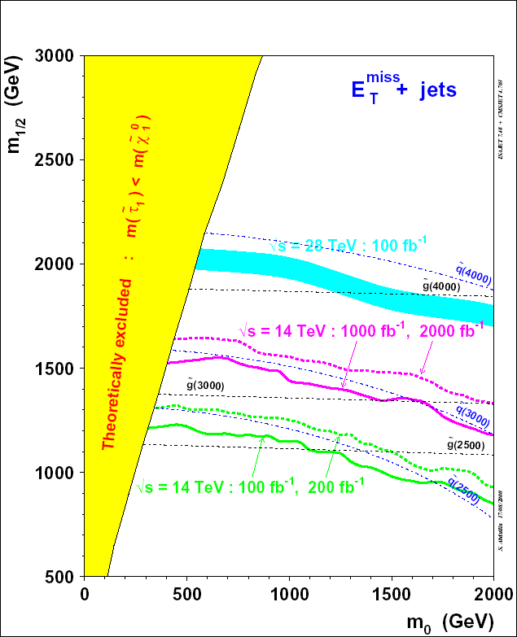
Figure 2: Mass reach for sequential electroweak Z bosons at the LHC showing the effect of a luminosity upgrade.
Figure 3: Contours of 5 σ discovery in the mSUGRA plane for Ao=0, tanβ=10 and μ<0.

Energy

In the case of an energy upgrade, there are even more substantial physics gains. While a luminosity increase has major implications for the detectors, an energy increase is much less demanding on detector performance.

A comparison of the mass reach for the SLHC and the energy doubled LHC is shown in Table 2. For these high mass cases a doubling of the LHC energy is more powerful than a tenfold increase in luminosity. In the case of the physics of a low mass Higgs boson, the energy increase is less advantageous. For a Higgs mass of 160 GeV the cross section only doubles if the LHC energy is increased to 28 GeV.

Table 2: Comparison of mass reach for the SLHC and the energy doubled LHC for selected physics processes. All numbers except for W_{L}W_{L} are in TeV.
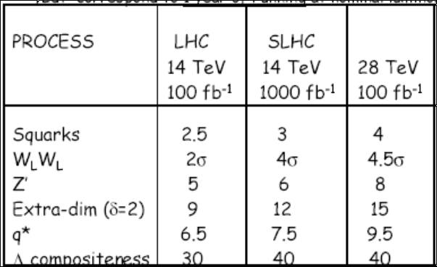
2. Detector Upgrades

Introduction
Detector upgrades will be required for three phases of the LHC research program: the operation of the baseline LHC as it and the experiments mature; the SLHC with luminosity increasing toward 10³⁵ cm⁻²s⁻¹; and the possible energy increase at a later date. We believe that the luminosity upgrade is very likely to take place on a time scale that requires a vigorous R&D effort to begin very soon, since the very high luminosity environment will require major changes in some detectors and complete replacement of others. The additional upgrades to deal with higher energy are less challenging, but over a long period of time, obsolescence will force detector, trigger and data acquisition system replacements with new technology.

Baseline lhc
From the beginning of detector system operations, which are starting now, to the time when an upgrade is likely is about ten years. During this period there will be operating experience with real-life conditions and steadily increasing luminosity, data rates and radiation doses. The baseline luminosity exceeds10³⁴cm⁻²s⁻¹, far higher than in any hadron environment ever attempted with full event measurement. Event analysis may reveal issues never anticipated in design and simulation. Even the nature of the physics encountered may open new opportunities for detector improvements. All past experience shows that a steady stream of essential work must be done in replacing or improving parts of the detectors, at a cost of a few per cent per year of construction cost, rising as systems near the end of their useful life.

Slhc
The extensive R&D required for the construction of the present LHC experiments gives us a good base for extending their performance to the conditions of the Luminosity Upgrade. Some present detectors such as central rapidity calorimeters and muon detectors will need little adaptation and the magnet systems are unchanged. The tracking systems will almost certainly need to be replaced, after intense R&D programs to meet the demanding granularity and radiation specifications. Certainly the experience of the present construction project shows that some very difficult technical problems have required U.S. resources to find a solution. If the subsequent step is to increase the collision energy, with a reduction in luminosity, the further upgrades needed are smaller.

Tracking
The high luminosity of the SLHC requires two kinds of changes in the tracking, relating to the increase in the number of tracks and in the radiation dose delivered to the tracking system. Greatly improved time resolution will not be required. The increased number of particles per bunch must be dealt with by increased granularity. The number of “pixels” in a given detector plane must be increased so that the probability of a given pixel being struck by more than one particle is small. The granularity must be sufficient to allow the large number of tracks (~10⁴, similar to a heavy ion event) in a single crossing to be reconstructed, and then the precision of the tracking system permits all of them to be assigned to distinct collision vertices. In this way, the quality of the tracking can be maintained at a luminosity of 10³⁵cm⁻²s⁻¹. This does require a new tracking system, probably demanding new technology. These new developments will allow other improvements to be incorporated, such as increased precision at small radii, with improved b-particle measurement and possibly τ-particle tagging. Increased precision at large radii compared to the present detectors will improve the fractional accuracy at the highest momenta. Enhanced triggering capability may be desirable. Designs that reduce the amount of matter in the tracking systems should also be possible with further development.

The radiation dose for which the present baseline detectors are designed is already very high for the materials and configurations used. Lengthy R&D efforts have yielded solutions that are viable, but less than ideal. Material studies and processing of silicon sensors have succeeded beyond initial expectations, and the commercial development of deep sub-micron feature-size electronics has allowed great progress in the radiation hardness of the readout. Still, the present designs will require the detectors be replaced periodically. A factor of ten increase in the radiation level will require new ideas for essentially all aspects of the tracking detectors, particularly those closest to the interaction point. While it is possible that more work on the material properties may allow the current designs to meet the requirements, changing the architecture of the silicon detector system may give solutions more advantageous in a number ways. Several suggestions are already being studied. The detector geometry may be changed by using the third dimension in the silicon and reorienting the charge collection geometry.

Other efforts focus on the monolithic planar process that has given such great advances in the last decades, attempting to integrate the sensor and readout in a monolithic structure, which combines the radiation resistance of the deep sub-micron technology with the evident advantages in efficiency of connections, mechanical properties and construction. An ambitious and adequately supported R&D effort would be required to achieve these goals, but the final result would be tracking systems that offer performance better than the present baseline, even at much higher luminosity. We note that R&D on tracking systems currently in production for the LHC began more than a decade ago. The challenges of the SLHC are certainly greater. These new detectors would surely have applications beyond particle physics.

Calorimeters
The calorimeters in the central region of rapidity are already sufficiently granular and in the main robust to radiation, though some on-detector electronics with large channel count will need to be rebuilt, after R&D has identified solutions to increased radiation levels. The evolution of the calorimetry in the more forward angles is governed by the pile-up of particles and jets in a given beam crossing time. This sets limits on performance, but it is essential to maintain the measurement of missing energy. The fluctuations of the pileup will limit the precision of the missing energy measurement. Once again, the existing forward calorimeters are probably adequately granular, and some are adequately robust, but others may need upgrades.

Muons
The muon detectors in the central region should be able to deal with the higher luminosity, depending of the lessons learned from operation in the real environment. The muon system in the more forward directions will need some upgrades. More shielding may be called for in some cases, and the rates of random hits as well as muon tracks will require attention in the forward direction. The emphasis on very high mass scale means that the muons of greatest interest are more concentrated in the central region, and that retaining full performance in the forward directions has somewhat lower priority than in the initial phase of the LHC. In practice, full angular coverage is found to be valuable, to observe complete events with more complex decay chains and, even for two body lepton decays, to measure angular distributions sensitive to the quantum numbers of new particles

Trigger - DAQ
The steadily increasing luminosity of the LHC in the baseline phase as well as for the SLHC means that there must be changes with time in the trigger and data acquisition system. The rapid evolution of commercial hardware in this area makes this inevitable and cost effective in any case. The improvements in hardware performance make us confident that this can be done in a very cost effective manner.

Integration
It is essential to recognize that the upgrades are sufficiently major to require an important effort in overall system integration. It is sufficient to note that the tracking systems are the most demanding in the areas of services, support, beam pipe integration and interfaces with surrounding systems. The fact that tracking systems are new implies that a major and difficult job will be required in this area, and it will be prudent to assume that there will be significant U.S. involvement in this task. Recent CDF and D0 experience indicate that this area is critical.

3. Accelerator Upgrades

Luminosity Upgrade of the LHC
An increase in LHC luminosity, to as much as 10³⁵ cm⁻² s⁻¹, appears feasible [2,3]. Such an increase can be achieved with upgrades that involve replacement of equipment in the LHC insertions or in the injector complex, but the large investment in the main accelerator arcs and most of the infrastructure would continue to be used. These upgrades would cost a only a small fraction of the original cost of the LHC, and would require only relatively modest down-time, on the order of a year, to install.

To achieve a factor of ten increase in luminosity, a number of accelerator systems will need to be upgraded, each of which will contribute a factor to the higher luminosity. Substantial R&D on accelerator components, and studies to understand the limitations of the current configuration will be required before the specific machine modifications can be proposed. However, a key element of any luminosity upgrade will be the replacement of the interaction region (IR) final focus system [4] with higher performance magnets, larger aperture quadrupoles in particular. The upgraded IR will allow a reduction in β*, increased flexibility in crossing angles, and the ability to deal with the higher radiation load that is a by-product of the higher luminosity.

The U.S. National Laboratories are uniquely positioned to lead the development of the new IR design and of the magnets that it will require. Our work on the design and construction of the existing IRs gives us important understanding of their limitations and of the measures to be taken to alleviate those limitations. The new IRs will require magnets based on Nb₃Sn superconductor, to provide both higher fields and greater temperature margin against radiation heating than is available with NbTi. The R&D programs at BNL, Fermilab, and LBNL put the U.S. Laboratories at the forefront in the development of high-performance Nb₃Sn accelerator magnets. The specific magnets required for a new IR will take many years to develop, and this work must begin soon to ensure that they are ready when the LHC upgrades are to be implemented.

We are in the process of establishing a formal collaboration with CERN on upgrades to the LHC interaction regions. The collaborative work will be carried out by Fermilab, BNL and LBNL as part of the U.S. LHC Accelerator Research Program. The initial program will be the exploration of several possible optics and layouts of new interaction regions, including investigation of relevant accelerator physics issues and the studies of conceptual designs of the magnets required by them.

We have conceptual designs for new IR quadrupoles which, with the improvement of Nb₃Sn performance expected in the coming years, provide the same gradient as the IR quadrupoles currently being built by Fermilab and KEK, but with an aperture as large as 110 mm. These could allow up to a factor of three decrease in β* with corresponding increase in luminosity, and would be able to operate with the expected radiation heating up to a factor of ten increase in luminosity. Studies are also being done for the beam separation dipoles for the “dipoles first” layout, in which there is no superconductor on the mid-plane, where the peak energy deposition occurs.

Following these studies, we will begin R&D to develop the key magnet required by the chosen IR layout, most likely a very large aperture quadrupole. Whatever the chosen design, it will substantially extend the state-of-the-art in accelerator magnets. A intensive, focused R&D effort to develop the specific design, including all features required for installation and operation in the accelerator will begin in 2005 or 2006, culminating in the construction of one or two full-scale prototype magnets in prototype cryostats in the first years of the next decade. The deliverable from this work would be the design of a new interaction region, and a fully engineered design for the final focus quadrupoles, ready for manufacturing. This effort will also advance U.S. leadership in superconducting magnet technology for high-energy accelerators.

Energy Upgrade of the LHC
Once the LHC with upgraded luminosity has been fully exploited, it will be necessary to go to higher energy to extend our understanding of nature. The LHC nominal energy of 7 TeV is achieved with a dipole field of 8.3 T. The “ultimate” field of the dipoles is 9 T, which if reached would yield a beam energy of 7.54 TeV. To increase the energy further, it will be necessary to replace the LHC with a new machine with higher field magnets. Using Nb₃Sn superconductor, it appears possible eventually to reach a dipole field approaching 17 T. This would allow accelerator operations, with a reasonable margin, at 14-15 T, corresponding to a beam energy of around 12 TeV in the LHC tunnel. The goal of 17 T, however, is well beyond the current state-of-the-art. The highest field yet achieved in a dipole-like geometry is 14.7 T, a result obtained by LBNL [5]. An extended and vigorous R&D program will be necessary before a higher energy machine can be proposed for the LHC tunnel. The R&D must both achieve the very high field required and result in cost effective magnet designs for main arc dipoles and quadrupoles.

This upgrade is likely to be expensive. In addition to a new machine replacing the LHC, a new high-energy injector will be required, either replacing the SPS or intermediate between the SPS and the new LHC. The cost of building the new LHC complex is likely to be at least as large as that of the LHC itself, and involve a shut-down for construction of length comparable to that between the end of LEP operations and the turn on of LHC. Assuming that the new LHC would be built only after the full exploitation of the luminosity upgraded LHC, construction is unlikely to start before the early 2020’s. It is not yet clear if the additional physics reach of the increased energy will justify the cost of this machine. No decisions can be made before the necessary R&D has been done, physics results from LHC and from a possible companion e⁺e⁻ collider are known, and the potential for building a higher energy p-p collider in a dedicated tunnel is understood.

4. Cost and Schedule

The following schedule was given in outline in the recent HEPAP Subpanel report.

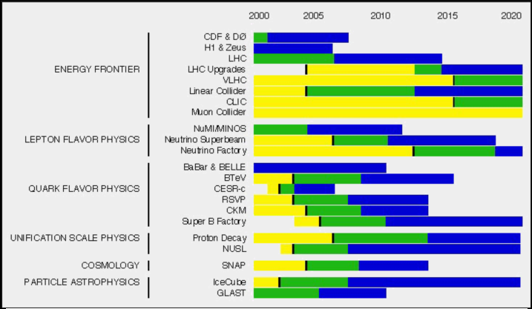

The detector upgrades for the SLHC will likely take ~ (6-10) years. Clearly, the time to start the R&D needed for truly new detector technologies (e.g. the inner tracker) is now. The LHC accelerator upgrades ( high field IR quadrupoles for the SLHC in the case of the US) also need substantial time for R&D prior to production. The R&D should be started no later than 2005, with the aim to be complete by 2010. Production of components should be complete in about 2012 in order for commissioning to begin.

A formal cost estimate does not exist at this time, because the necessary R&D is not yet even begun. Nevertheless, a rough estimate can be made. The SLHC basically requires new tracking systems. These cost ~ $200 M each (ATLAS + CMS) in the US “metric”. Since the US is ~ 20% of the collaborations, the appropriate share would be ~ $80 M for the trackers. Adding improvements in calorimetry, muon systems, and trigger and data acquisition, we are led to a rough estimate of $100 M. The IR magnet system for the SLHC is estimated to cost $50M. The costs are quoted in FY03$.

References:

[1] F. Gianotti, M. Mangano , T.S. Virdee et al, Physics Potential and Experimental Challenges of the LHC Luminosity Program, CERN-TH/2002-078, April 1, 2002.
[2] F Gianotti, D. Green and F. Ruggiero – ICFA Presentations at CERN,
http://dsu.web.cern.ch/dsu/of/Icfaprog1.html
[3] O. Brüning et al., LHC Luminosity and Energy Upgrade: A Feasibility Study,
LHC Project Report 626, December 2002.
[4] T. Sen et al., Beam Physics Issues for a Possible 2nd Generation LHC IR,
Proceedings of EPAC 2002, Paris, France, p. 371.
[5] R. Benjegerdes et al., Fabrication and Test Results of a High Field, Nb₃Sn Superconducting Racetrack Dipole Magnet, Proceedings of the 2001 Particle Accelerator Conference, Chicago, Illinois, p. 208.

