Calorimeter Trigger:

The Wisconsin group built an integrated circuit that adds 8 13-bit numbers. This was developed in cooperation with Vitesse Corporation in GaAs technology. High speed GaAs technology was chosen because it has an ECL I/O capability and it can provide an opportunity to run sections of the trigger logic at four times the LHC clock frequency. This results in a considerable reduction of circuitry in the trigger data path. The functionality of this Adder ASIC circuit which was installed on the prototype Receiver Card has been verified in tests.

The Wisconsin CMS group subsequently put out an RFQ (UW Bid No. 99-0059R1) to engineer the 4 additional ASICs needed for the project and the production run of 503 Adder ASICs, only Vitesse responded and was subsequently awarded UW P.O. 552F904 for $423,820.

As another test of the implementation of our trigger system design we have constructed a backplane, shown in the front and the rear of the prototype crate in Figure 1 and Figure 2. The backplane has a right side trigger processing area with rear and front-mounted cards that exchange trigger data on 340-pin connectors. The left front-facing region is standard VME on 2 96-pin connectors, which is then carried to the other cards in the custom trigger data-processing section on single 128 pin connectors. We built a custom clock board to test the operation of the backplane. This test of the point-to-point differential ECL transmission indicated far end rise and fall times of 0.8 ns. We also constructed the prototype Receiver Card shown in Figure 3. The board is designed to receive data from the input 1.2 Gbaud copper links and transmit trigger data over the backplane to the prototype Electron Identification Card shown in Figure 4, as well as providing a full functional test of the Adder ASIC. Detailed and exhaustive tests of the Clock Board, Receiver Card, Backplane and Electron Identification Card in the past few months have verified the functionality of all components.

The design of the serial link mezzanine card and associated test board for the connection between the Calorimeter Regional Trigger and the ECAL and HCAL Trigger Primitive generation has completed the schematic capture stage and should be ready for testing in the Fall.

Muon Trigger:

Following a successful review of the Muon Port Card design and a decision on its connections and interfaces, the Rice group has made considerable design progress. The numbers and design of the Port Cards have been determined so that we can read out 2 muons per 20 degrees or 3 muons per 30 degrees out of the ME1 Port Cards. This accommodates triggering on the split strips in ME1/1. The Rice group has designed and built a small circuit board for testing optical links and investigating their properties, shown in Figure 5. This board is a prototype of the design for the optical link part of the port card and will be used test the various modes of operation of the links. They have begun testing optical links using the optical link test board. This board tests the various modes of operation of the links. Results from these tests will be used to finish the design of the prototype Muon Port Card. The Rice group has also built a board to supply clocks to trigger and readout modules, shown in Figure 6.

The UCLA group has produced a design document for the Sector Receiver, which provides complete details of the bit-flow. The Sector Receiver design passed a Design Review in March and is complete with the exception of the optical link usage and readout. The design layout is shown in Figure 7. There has been considerable progress on the physical implementation of the optical link synchronization, synchronization of the event data, and definition of readout registers.

The U. Florida group has made significant progress on the Muon Track Finder Sector Processor design following the review of the Sector Receiver and Sector Processor in March. The focus of these efforts was the design of the Track Assembler, the heart of the Sector Processor, shown in the overall design layout in Figure 8. It takes the information from all possible two-station extrapolations in the CSC system and determines the quantity and quality of trigger muons. Another area of design activity was the implementation of the extrapolation logic of the Sector Processor in the Xilinx Virtex series FPGA, which is latest series from Xilinx. The Track Assembler logic was also refined, and we have nearly a complete simulation of the Sector Processor written in Fortran and interfaced to CMSIM. The Florida group also was able to merge the SP-CSC processor with the SP-OVR processor. The former serves the endcap chamber alone, which the latter serves the overlap region covered by both barrel drift tubes and endcap CSCs. This was accomplished by simplifying much of the logic in the Sector Processor, which allows both processors to be put on one board. One of the many benefits of this merging is that the Muon Sorter will have only half the muons to sort (36). As a result of this work, the Track-Finder project successfully passed the milestone of the prototype design review on July 27, 28. A draft CMS note of the conceptual design has been produced with full specification of the input and output bits. The design review concluded that the merged single Sector Processor design that covers both endcap and overlap regions should be accepted. One consequence is that to make this design tractable, ME1 cannot be used in the overlap. This restricts overlap coverage down to an η of 1.0, instead of 0.9. However, this region is fully covered by the Vienna Drift Tube-based Track-Finder.

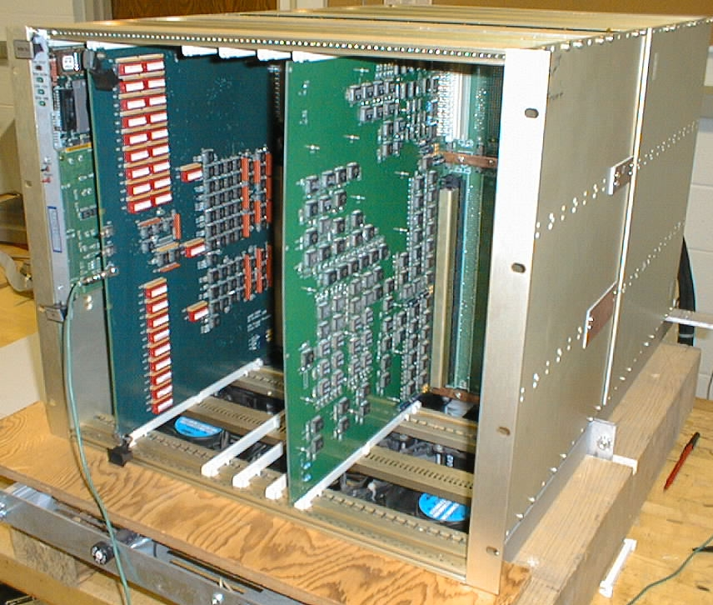
Figure 1: Front of Prototype Crate.
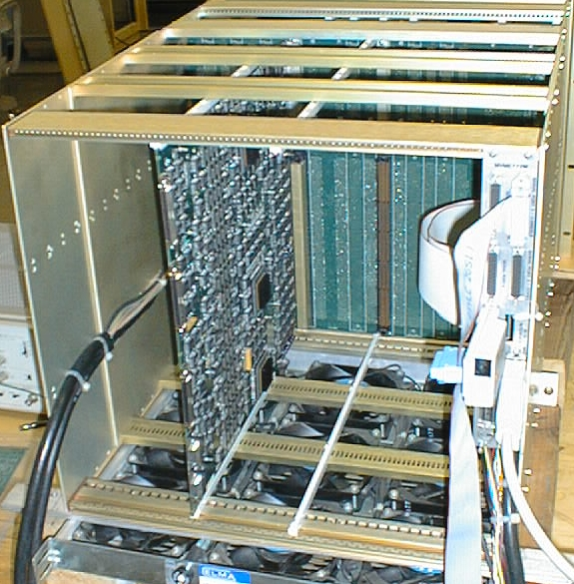
Figure 2. Rear of Prototype Crate with Receiver Card Installed

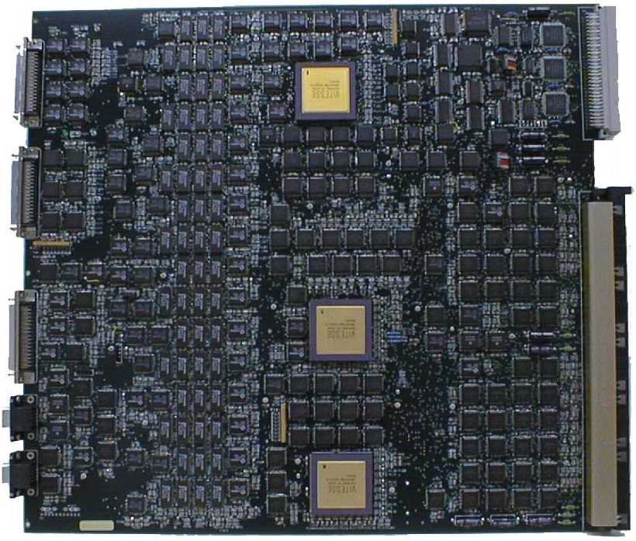
Figure 3: Prototype Receiver Card with 3 Adder ASICs installed.
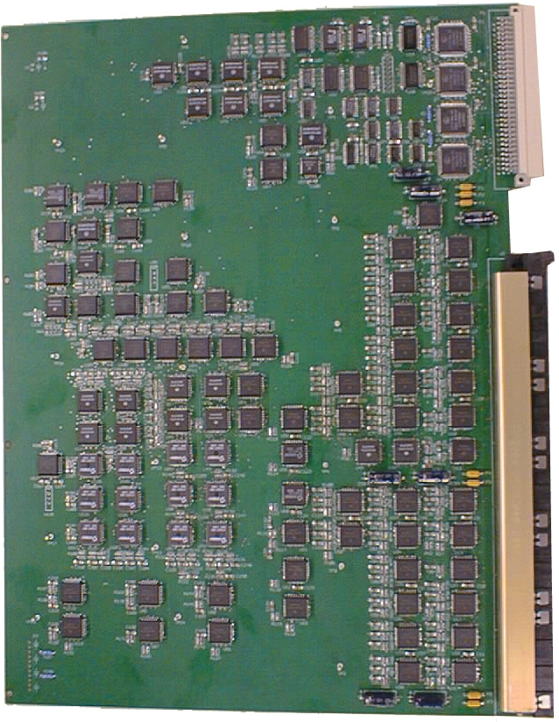
Figure 4. Electron Identification Card Prototype.

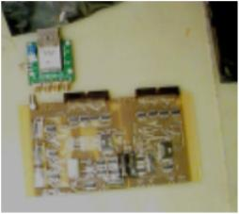
Figure 5. Muon Port Card optical link test board.
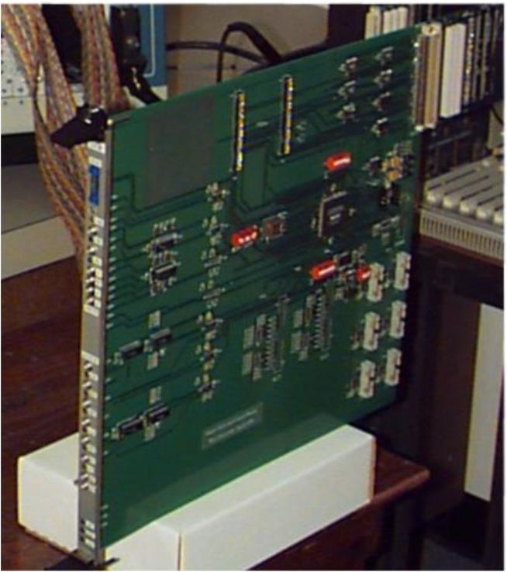
Figure 6. Muon Trigger Clock Board

Figure 7. Layout of Sector Receiver

Figure 8. Layout of the Sector Processor

